***JUNIPER NETWORKS***

***About Project:***

* UI based Juniper Website that allow user to fetch details of the traffic from the database between any two virtual networks.
* Flow statistics based on various select criteria. The backend renders the user request and formats it to an SQL query and fetches results by interacting with the database. The results are then rendered to the user. The database is implemented in SQL and it holds the flow table that holds the data that will be queried by the backend infra using rich JavaScript library NodeJs. Each Tuple has the following format:

|  |  |
| --- | --- |
| timestamp | 2016-04-12 14:03 |
| destination_ip | 10.2.1.3 |
| destination_vn | project1: virtual-network1 |
| direction_ingress | 0 or 1 |
| destination_port | 9117 |
| protocol | 6 |
| source_ip | 10.1.1.3 |
| source_vn | project2: virtual-network2 |
| source_port | 41322 |
| sum_bytes_kb | 15328 |
| sum_packets | 44000 |

* The user can request to display any of the above fields by selecting from drop down and narrow down the search by providing any field on the table as a filter criterion that is translated to where clause in SQL query.

***Details of my Project:***

* GITHUB Link:
* IDE used: WebStrom
* Technology used: NodeJs
* DB used: MySQL
* DB Connection details:

|  |  |
| --- | --- |
| Host | localhost |
| Port | 3000 |
| Schema | Juniper |
| Table | trafficflow |

***Assumptions made while building this project:***

1. Assumption made that for each (source and destination IP and source & destination VN) there would be only one record which would be updated for a total number of packets rather than multiple records being inserted.

2. Dealing with converting the timestamp in microseconds in Database was bit difficult hence I took "timestamp" attribute as datatype as Timestamp in DB (e.g.: "2016-04-12 14:03:50”).

3. The user can select single, multiple fields and can enter the time range (mandatory) and the system will fetch the data for that particular record.

4. The user can also make use of inserting particular values for any of the attributes and the system will fetch the data based on the selected fields, time range and entered data.

5. Output Result is in JSON format

SQL File:



***Step 1:***

Install WebStorm IDE

***Step 2:***

* Created a NodeJs Project Juniper

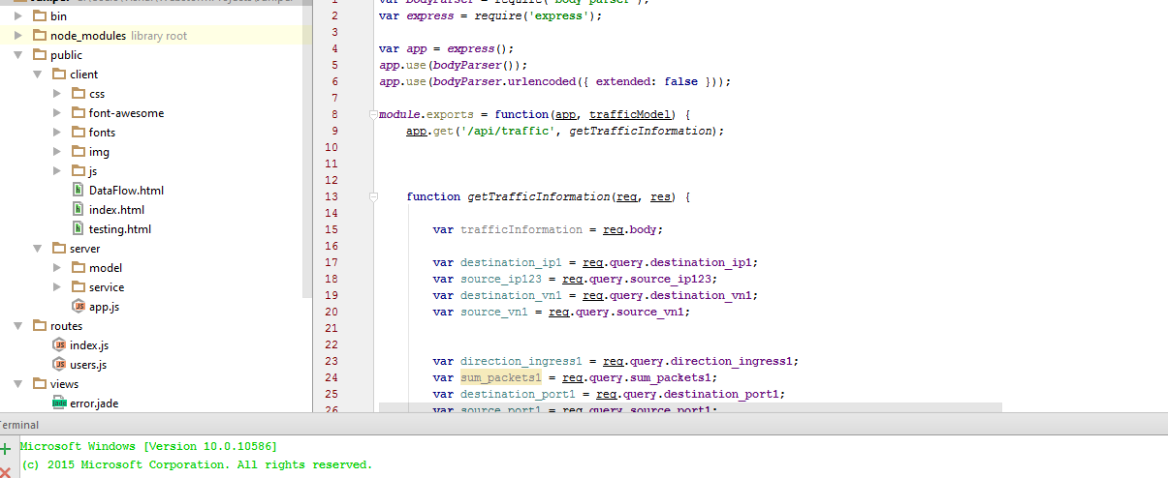

* Create a local connection with localhost port 3000

***Step 3:*** Designed Juniper UI

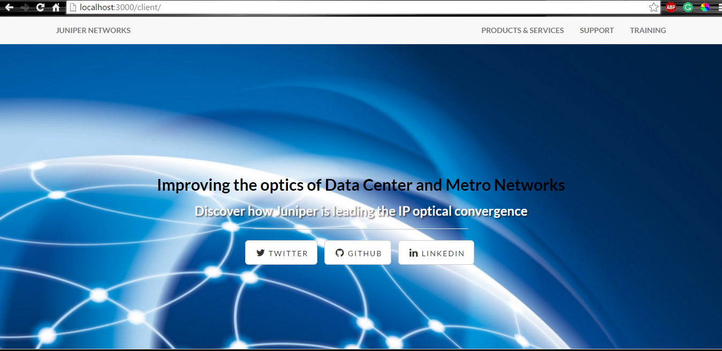

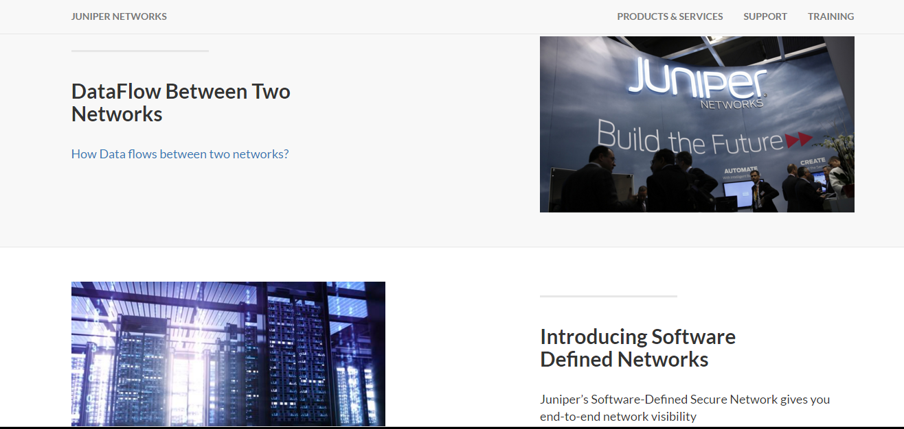





***Step 4:*** Click on second link – Data Flows between two virtual network

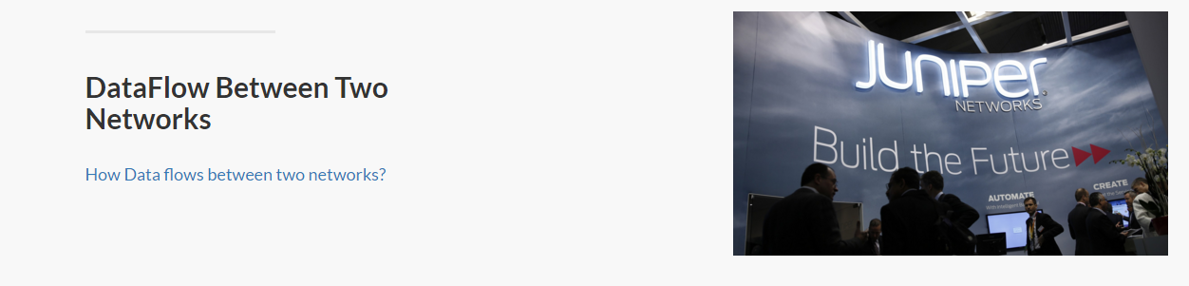

***Step5:***

Get Redirected to the main page:

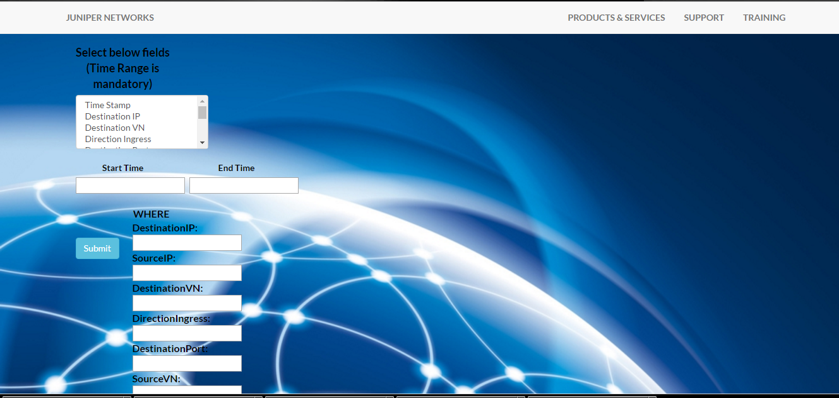

***Step 6:***

The user will select single or multiple fields, will enter the time range(mandatory) and can enter real time values in the above textboxes depending on the requirement, the system will fetch the data depending the input values and will display the output in the JSON format.

1. Selecting multiple fields and Time Range

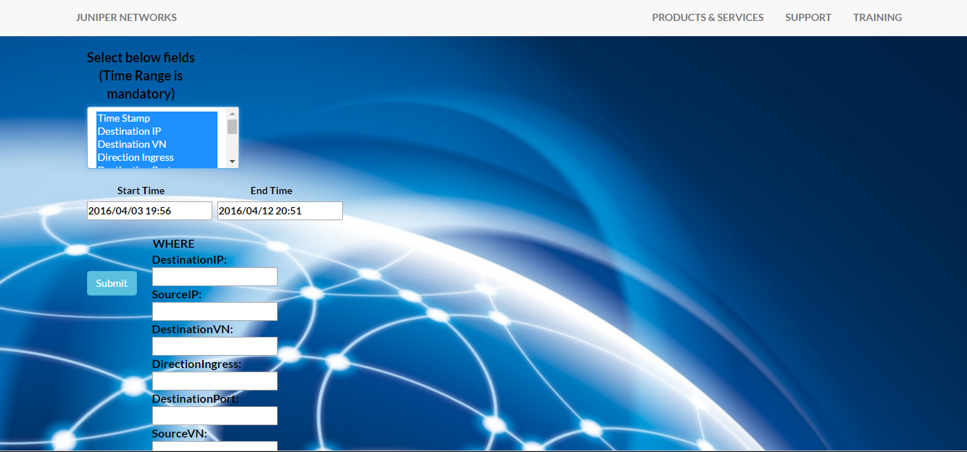

Output Result: System fetch the data from the database between time range start time - “2016/04/03 19:56” and end time – “2016/04/12 20:51”

The database has 3 records for the above time range.

***JSON OUTPUT:***

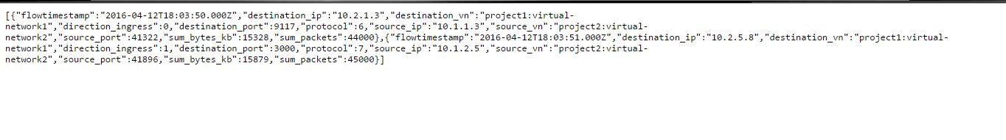

1. The user selects fields, enter the time range and enter Destination IP and Source IP:

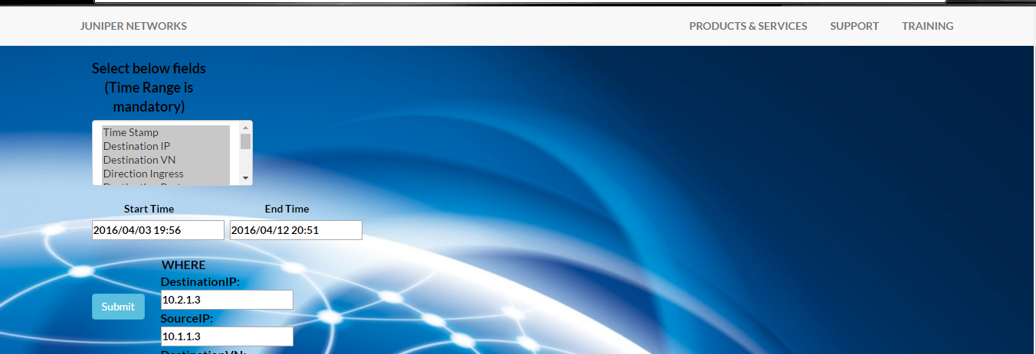

The database will fetch one record between the above time range and between DestinationIP-10.2.1.3 and SourceIP – 10.1.1.3.

***JSON OUTPUT:***

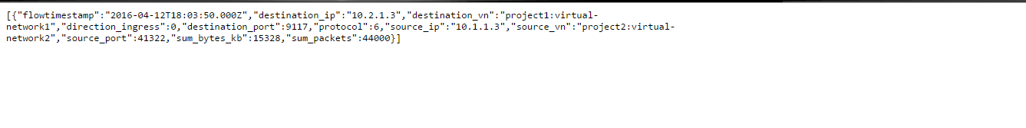

Database Query:

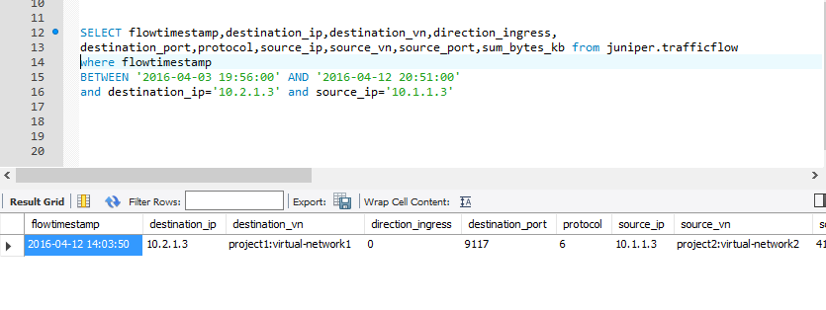

***Additional Notes:***

* NodeJs Query:

1. Capture the http request made by the user

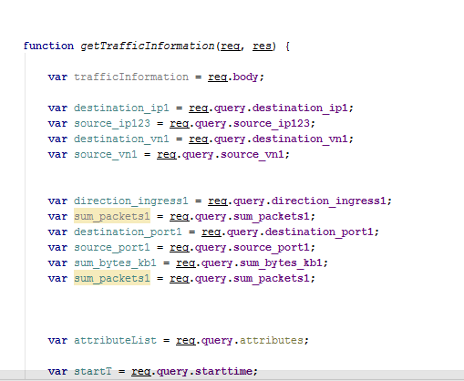

1. Check the condition for the input values

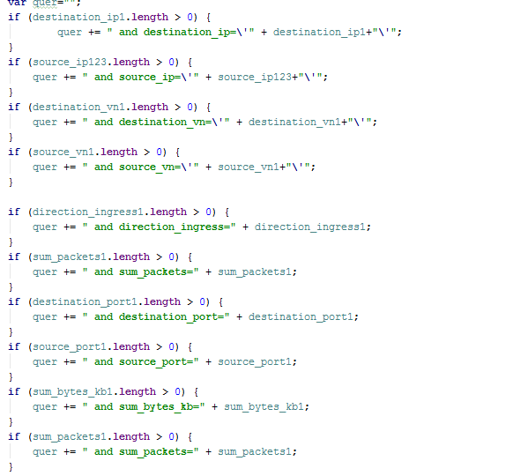

1. Run the Query

